There are 3 members in our group. We all made 2 sketches each based on what we think is important in the application. All the initial six sketches had different ideas and features of the app.

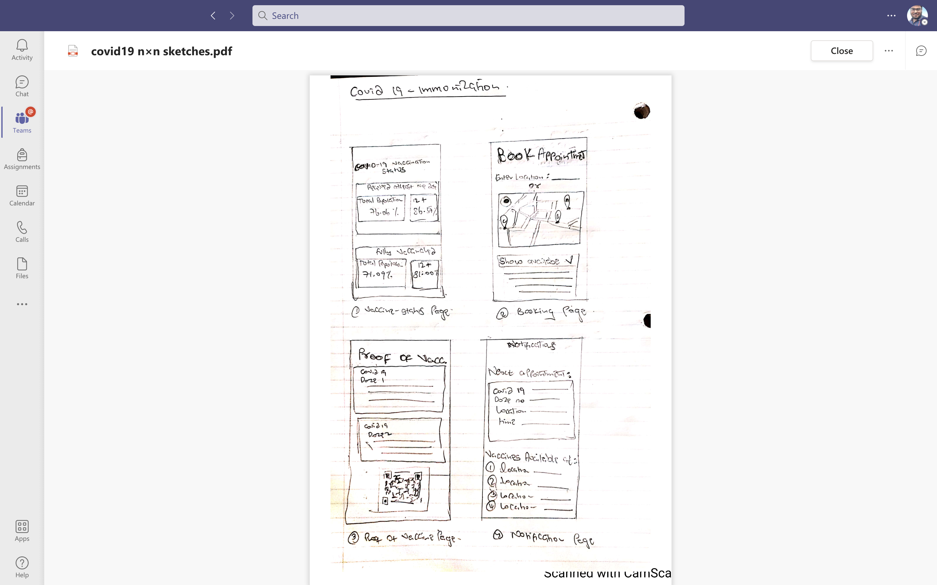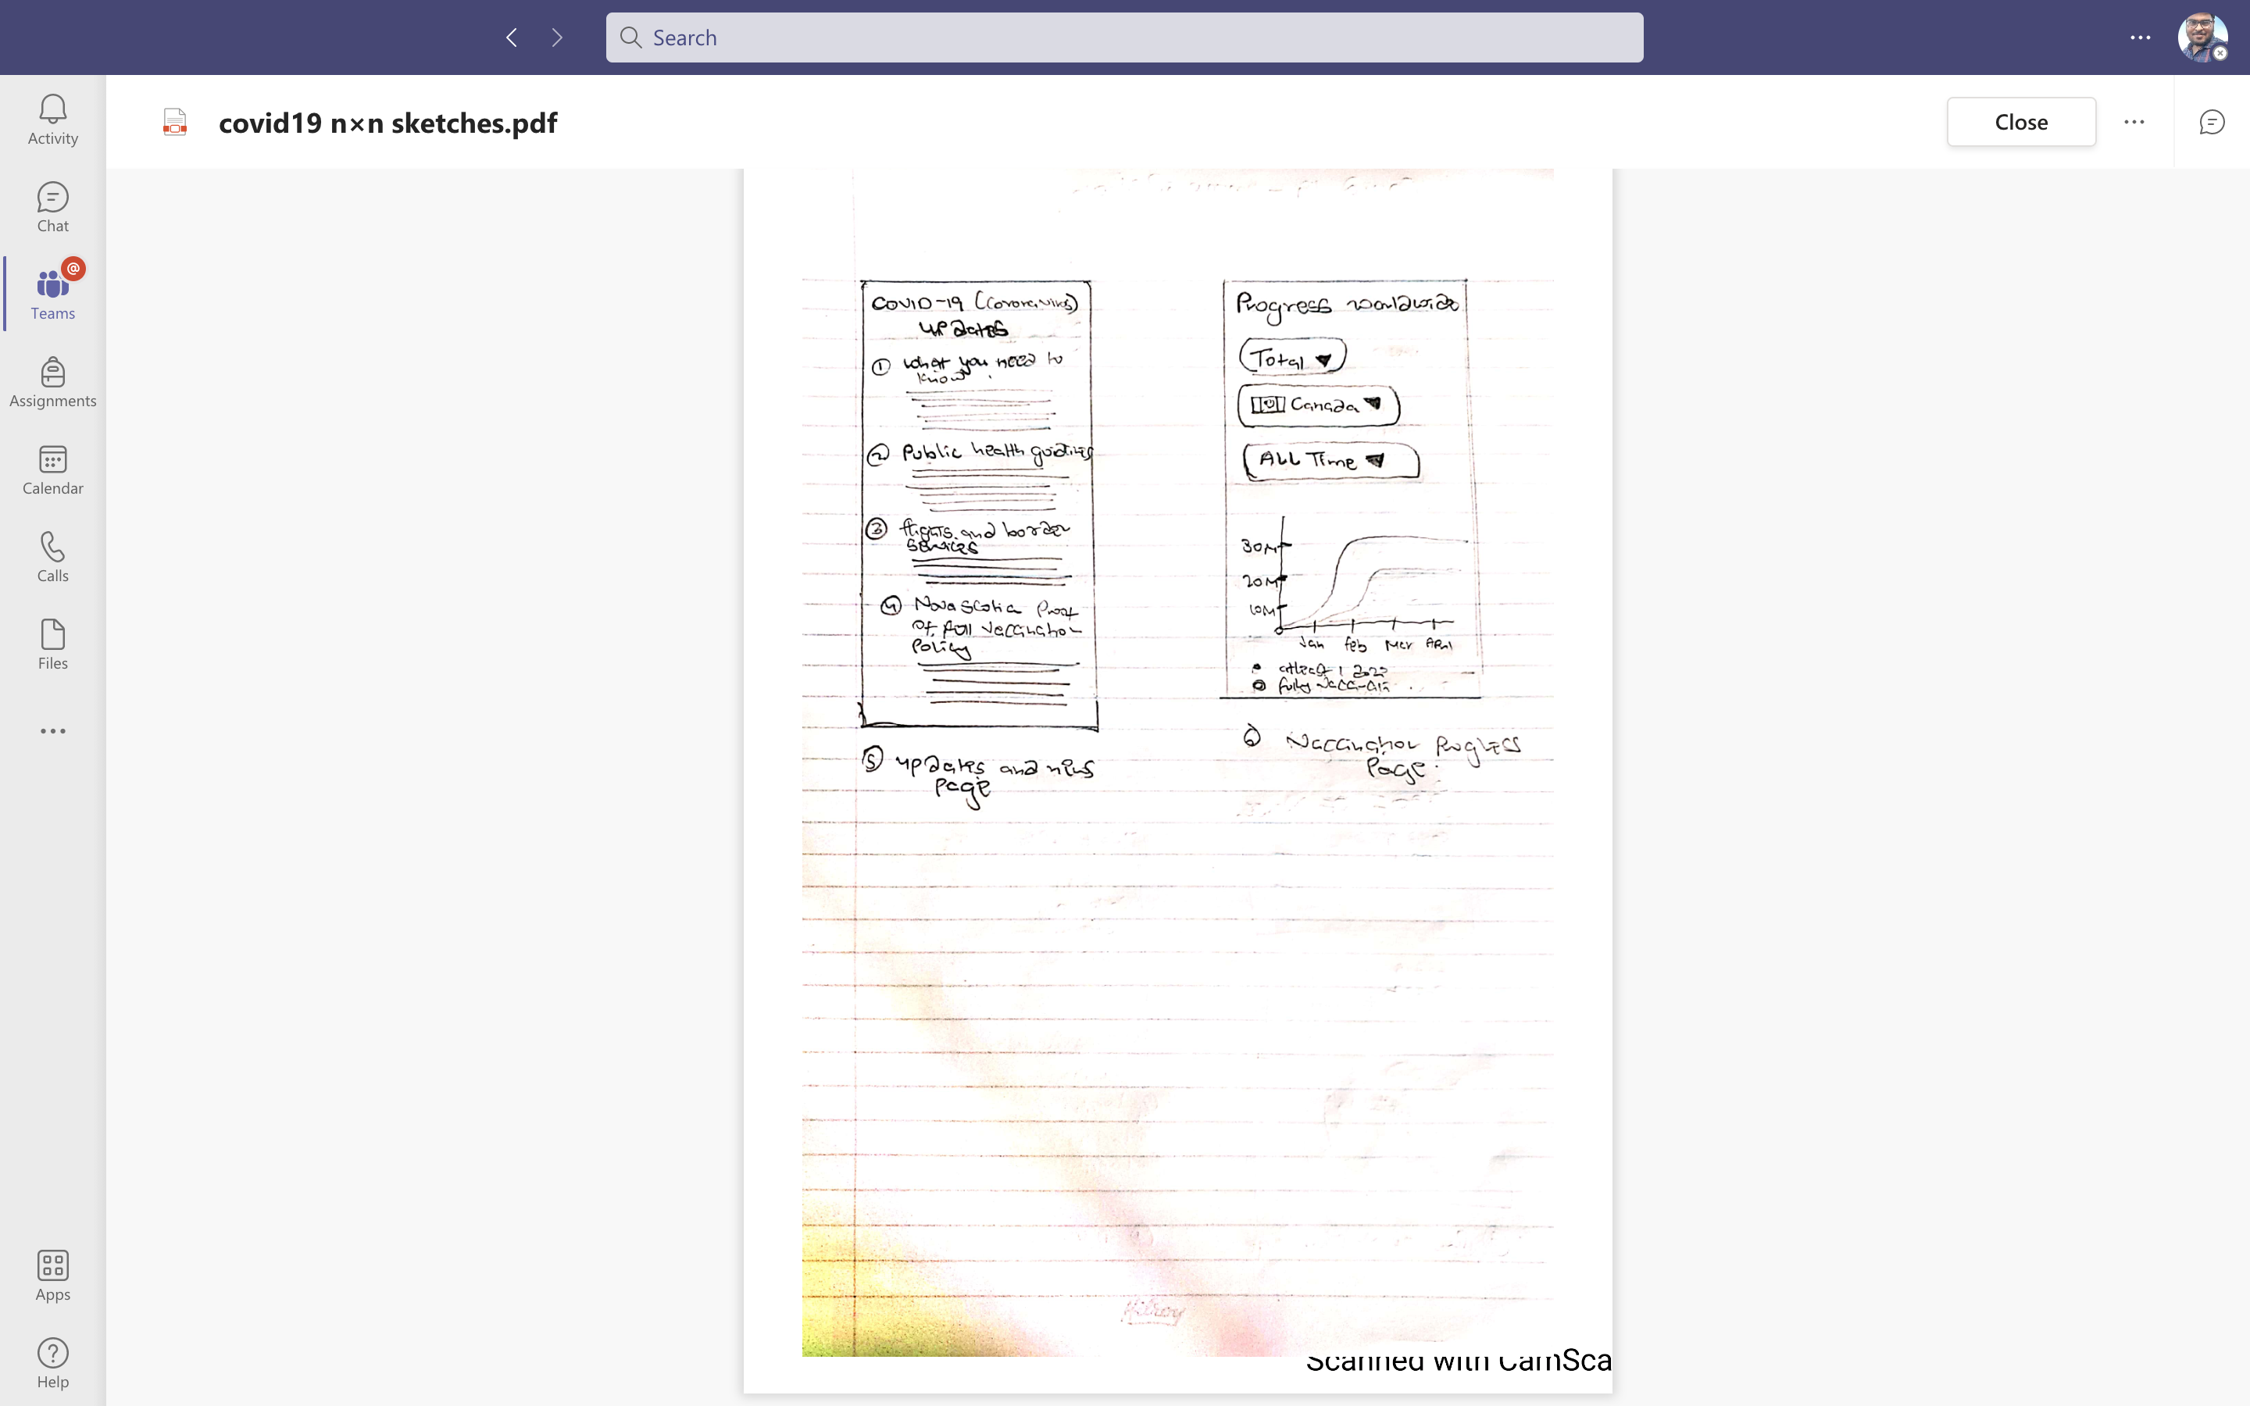

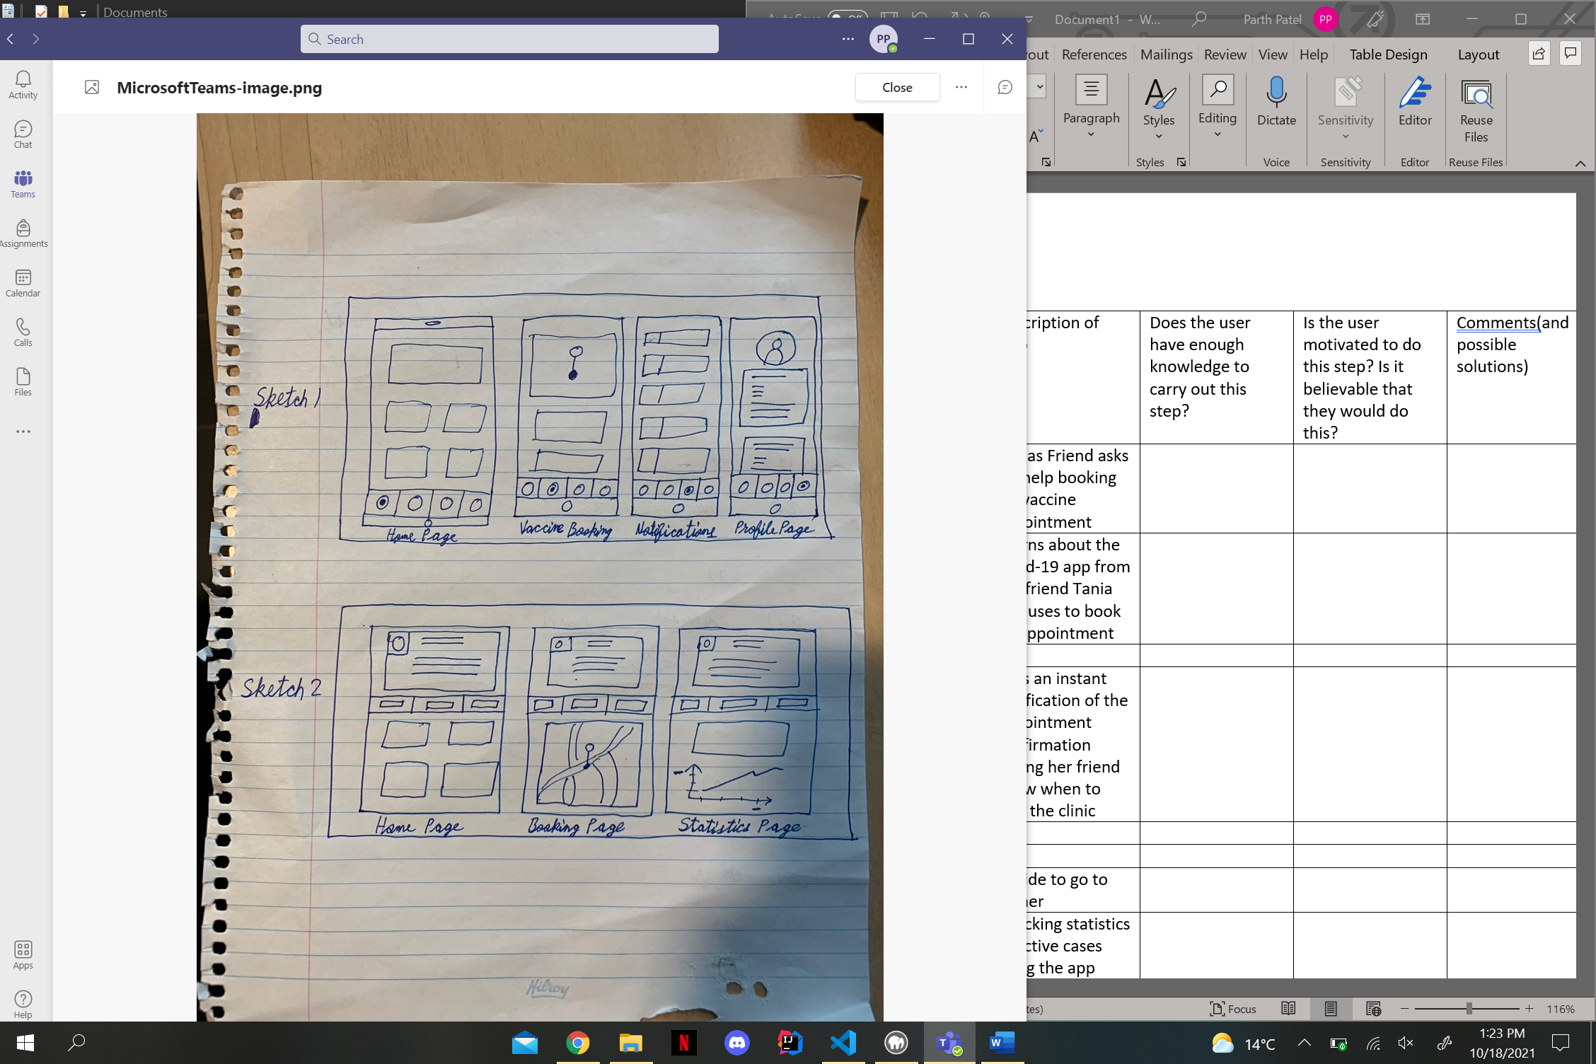

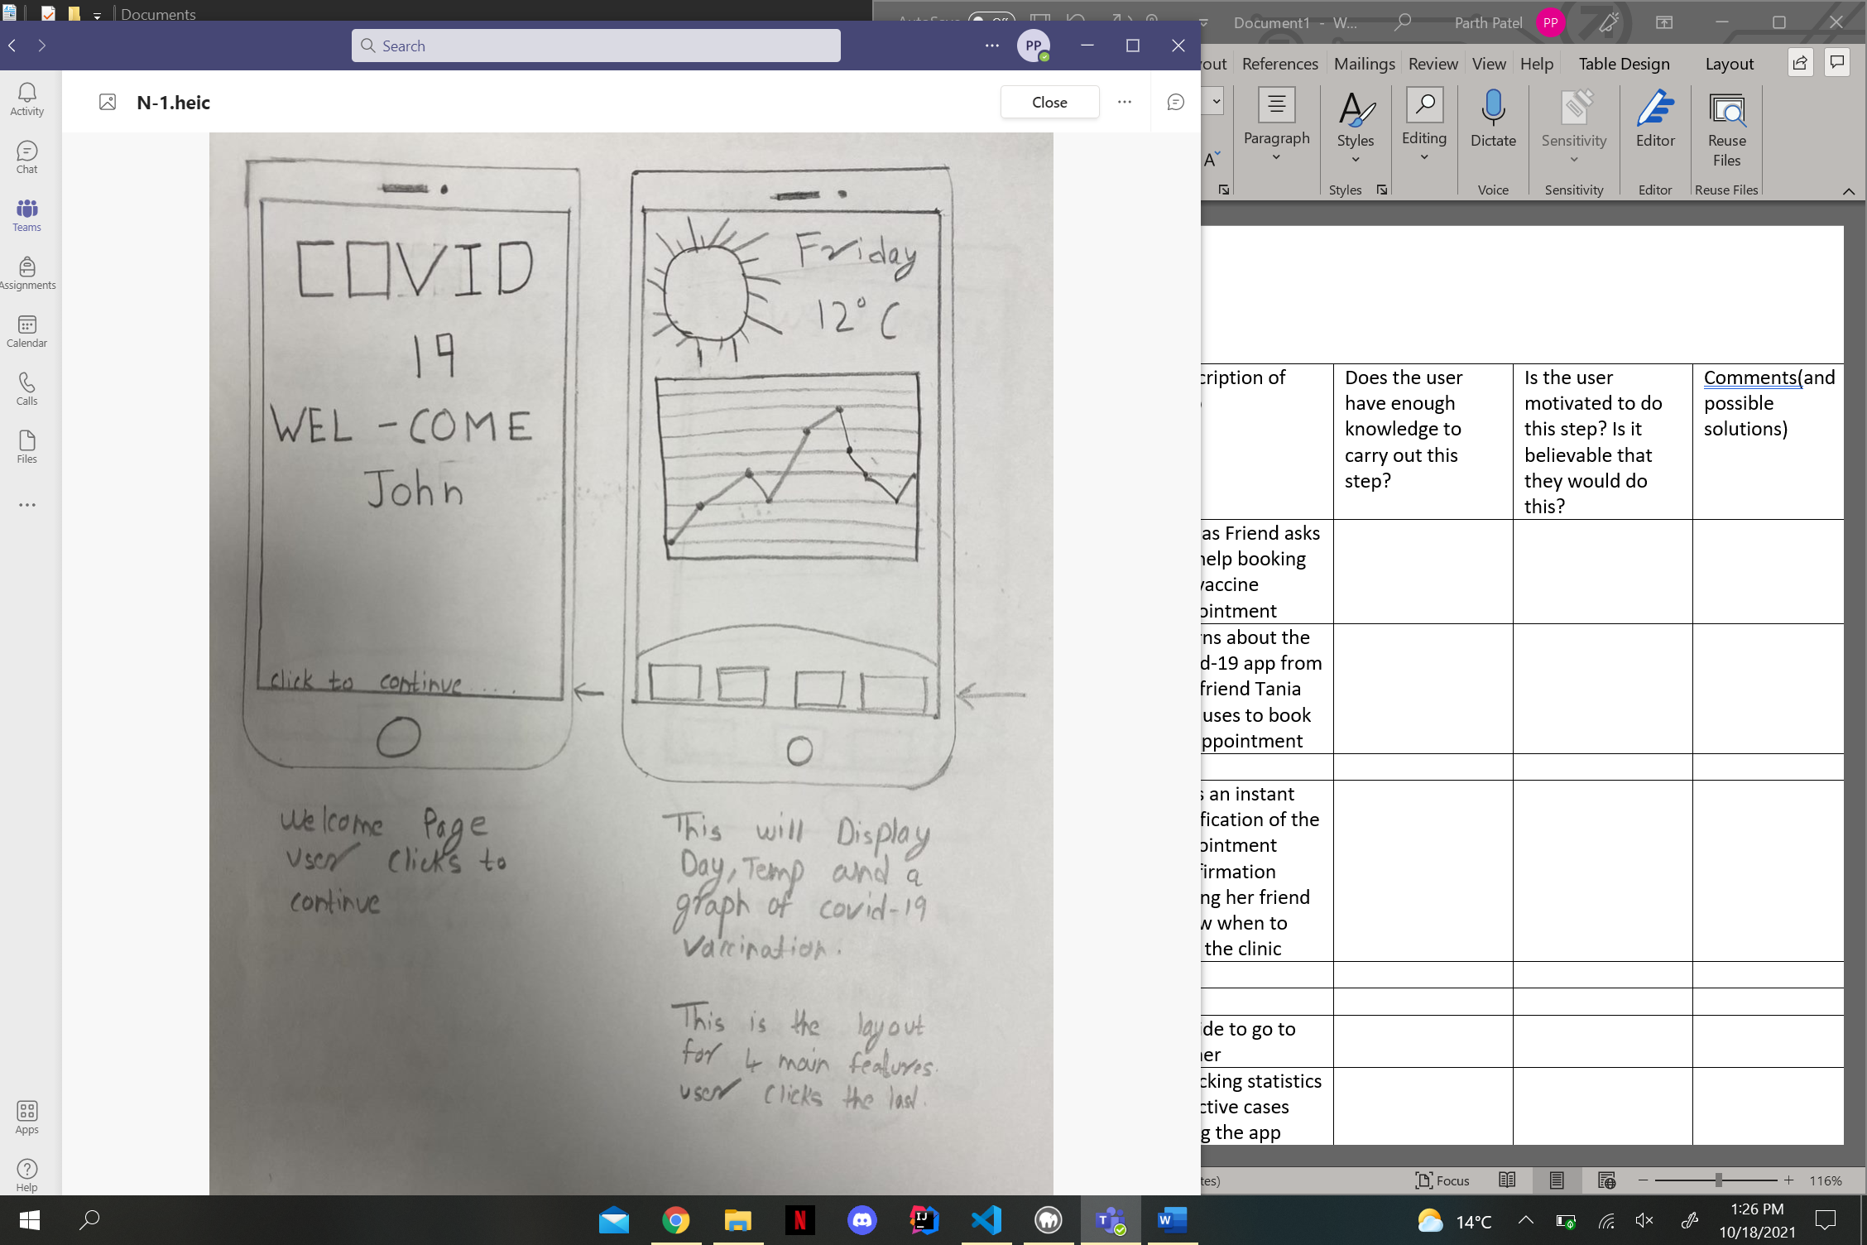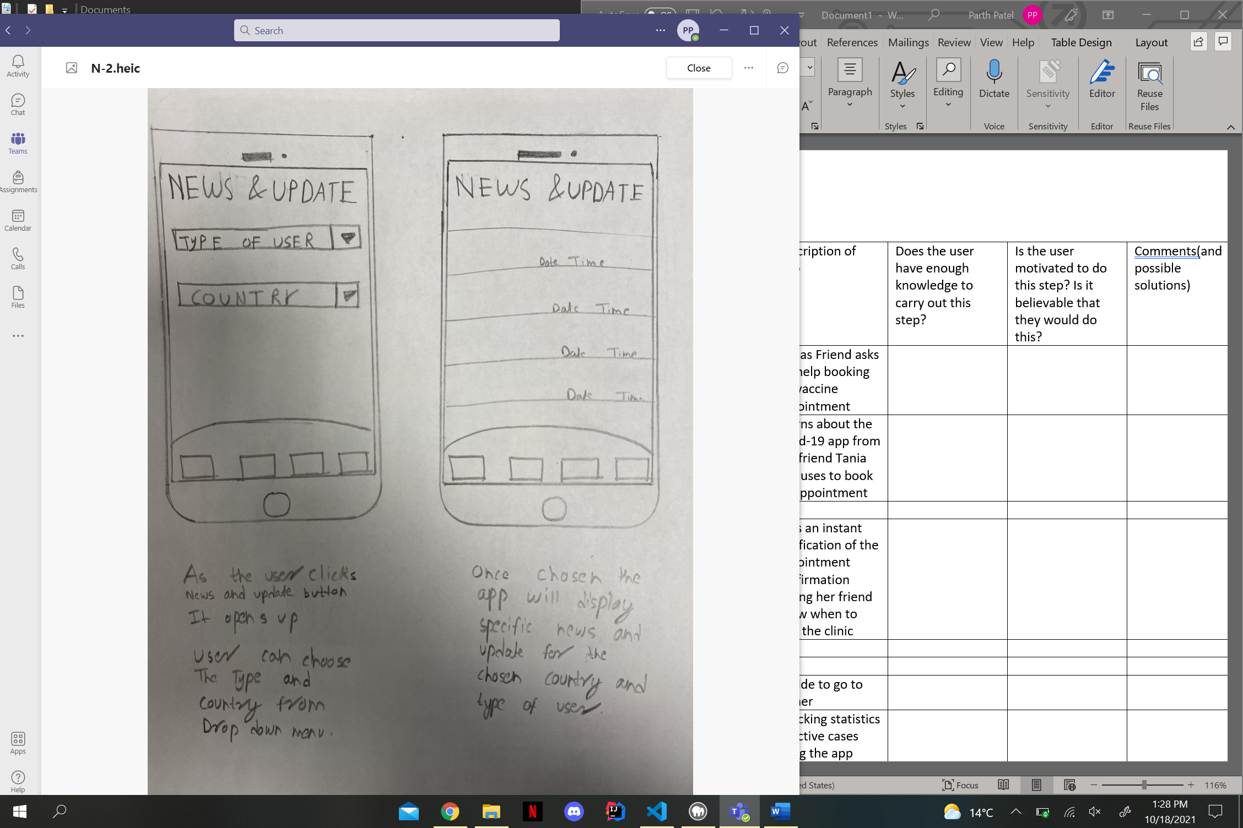

After doing this initial sketch and some brainstorming, we decided to go ahead with the sketch mentioned below.



We decided to go ahead with this sketch because we think that sketch is displaying more features, and this can be further improved. So, we again drew 6 sketches for the sketch we selected 2 each.

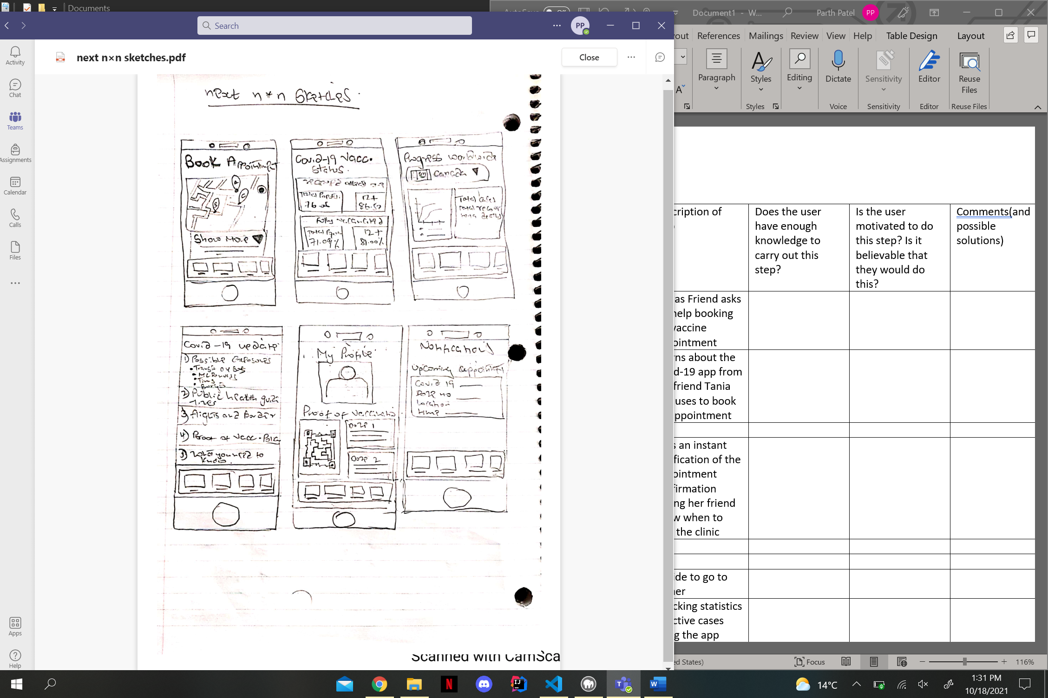 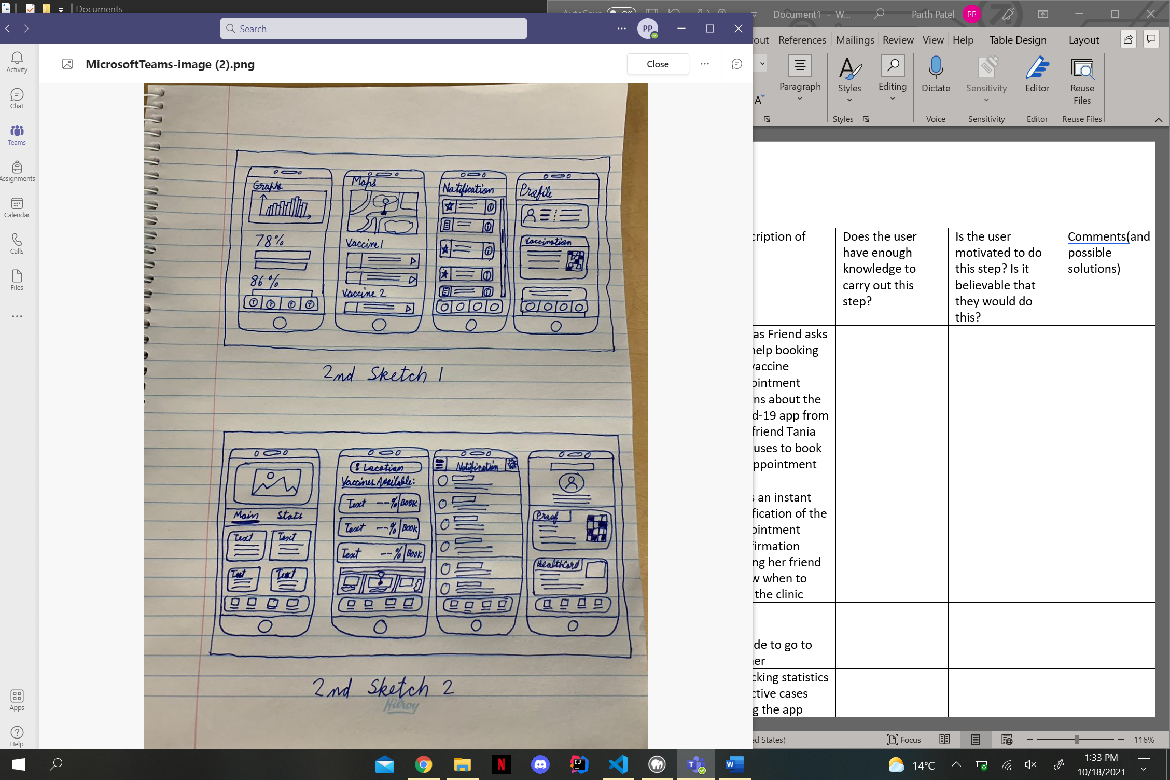

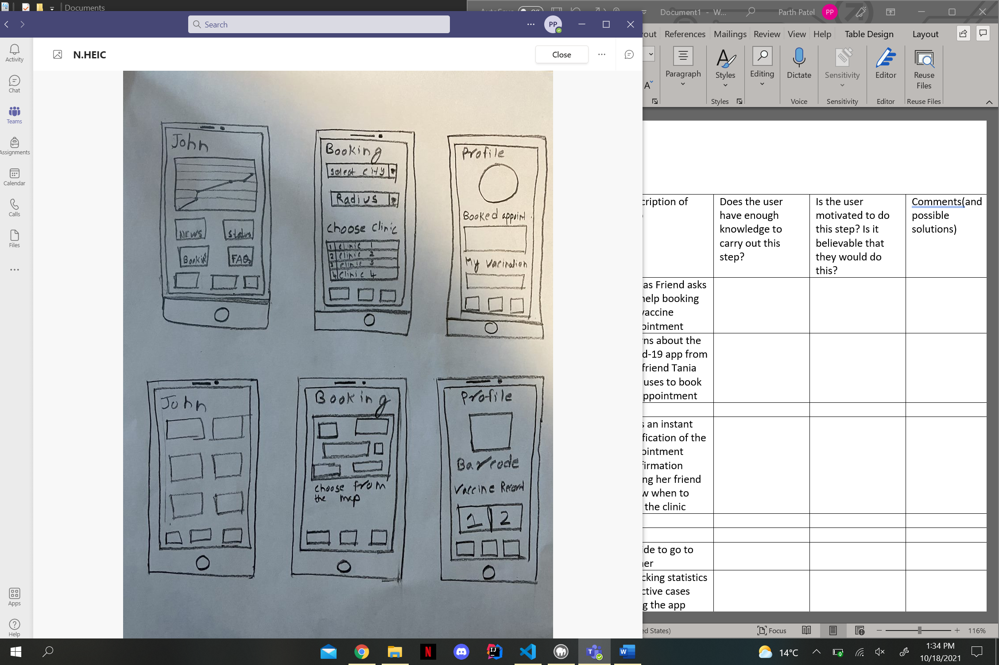

In each of the sketches we have made all the important features in the different layout what we feel is more attractive for the user. After doing the 2nd set of n sketches, we again did discussion and brainstorming and finalized a sketch.

After this we started our scenario, task and storyboard.